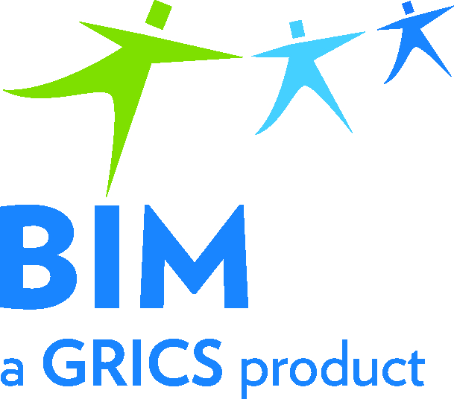 | Participation Form  BIM – VOCATIONAL TRAINING  Commencement of Work to Update  Evaluation Specifications and Examinations
To be returned by email before June 3, 2020
to Lucie Rose-Bickel
rosel@grics.ca
We invite you to participate in the preliminary work for updating evaluation specifications and examinations in the DVS 5731 Accounting program of study. This includes the determination of evaluation specifications (100 marks) and updating or developing examinations.

Please provide us with the name and contact information of a designated person. If more than 1 participant, please include a primary contact who will receive all correspondence. Please complete one form per vocational training centre.

Program | Vocational Training Centre | Name of Primary Contact | Coordinates  (Telephone/Email)
Accounting
DVS 5731

List five competencies for which you would be interested in determining the evaluation specifications and the updating and/or development of examinations. We will, as much as possible and depending on participation, try to respect your choices.

Once all the forms are in, we will assign you one or more competencies along with the necessary documents to develop the examinations. Then, we will forward you a training video capsule and preparatory documents with deadlines for which to submit the work.

Choice 1:
Choice 2:
Choice 3:
Choice 4:
Choice 5:

For any questions: 514 251-3700

Accounting (DVS 5731): Maria Pina Mercogliano – extension 3665
Comptabilité (DEP 5231): Lucie Rose-Bickel – extension 3885

The BIM-VT Team thanks you for your continued support and collaboration!

