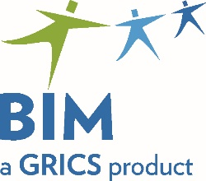 | Participation Form  BIM – VOCATIONAL TRAINING  Commencement of Work in Preparation  for the Development of Examinations
To be returned by email before October 14, 2022
to bim@grics.ca

We invite you to participate in the development of examinations in the AVS 5873 – Secretarial Studies-Legal program of study.

Please provide us with the name and contact information of a designated person. Please complete one form per work team.

Program | Vocational Training Centre | Name of Primary Contact | Coordinates  (Telephone/Email) | Date of Program Implementation
AVS 5873
Secretarial
Studies-Legal

List four competencies for which you would be interested in developing examinations for.

We will then assign you one or more competencies along with the necessary documents to develop the examinations. We will, as much as possible and depending on participation, try to respect your choices. Then, we will forward you with additional information and deadlines to submit the work.

Choice 1:
Choice 2:
Choice 3:
Choice 4:

For any questions: 514 251-3700

Secretarial Studies-Legal (AVS 5873): Maria Pina Mercogliano – extension 3665
Secrétariat juridique (ASP 5373): Sonia Roy – extension 3794

The BIM-VT Team thanks you for your continued collaboration!

