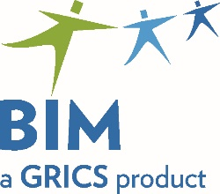 | Participation Form  BIM – VOCATIONAL TRAINING  Commencement of Work in Preparation  for the Development of Examinations
To be returned by email before April 19, 2023
to rosel@grics.ca

We invite you to participate in the development of examinations in the DVS 5882 – Soudage-assemblage (new Welding and Fitting program) program of study.

Please provide us with the name and contact information of a designated person. Please complete one form per work team.

Program | Vocational Training Centre | Name of Primary Contact | Coordinates  (Telephone/Email) | Date of Program Implementation
DVS 5882
Soudage-assemblage (new Welding and Fitting program)

List five competencies for which you would be interested in developing examinations for.

We will then assign you one or more competencies along with the necessary documents to develop the examinations. We will, as much as possible and depending on participation, try to respect your choices. Then, we will forward you with additional information and deadlines to submit the work.

Choice 1:
Choice 2:
Choice 3:
Choice 4:
Choice 5:

For any questions: 514 251-3700

Maria Pina Mercogliano – extension 3665

The BIM-VT Team thanks you for your continued collaboration!

