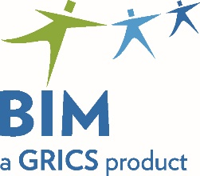 | Registration Form  Evaluation Specifications Validation Session  Phase 1: Competencies 1 to 10
To be returned by May 3, 2021
to Claire Soucy
by email
soucyc@grics.ca
Program | Dates | Location
Pastry Making − DVS 5797  Pâtisserie − DEP 5297 | May 19, 2021  9:00 a.m. to 4:00 p.m. | Virtual Meeting  You will receive a link allowing you to access the meeting a few days before it takes place.

School Board:
Centre:
Participants and Emails:
Person Responsible:
Email:
Telephone:

Thank you for your collaboration!

