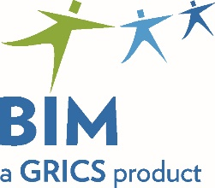 | Registration Form  Evaluation Specifications Validation Session
To be returned before October 12, 2021
to Claire Soucy
by email
soucyc@grics.ca
Program | Date | Location
Pastry Making − DVS 5797  Pâtisserie − DEP 5297 | October 19, 2021  9:00 a.m. to 4:00 p.m. | Virtual Meeting  You will receive a link allowing you to access the meeting a few days before it takes place.

School Board:
Centre:
Telephone:
Responsible:
Participant:
Email:
Participant:
Email:

Thank you for your collaboration!

