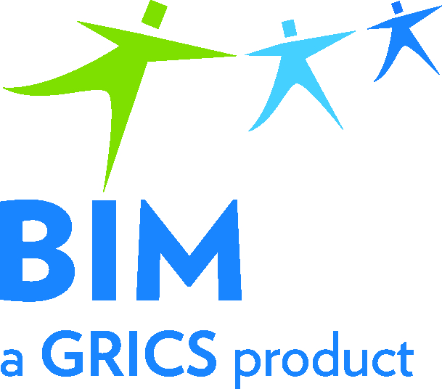 | Registration Form  31st Annual General Meeting  BIM − Vocational Education 2020
To be returned by email to
bim@grics.ca

Virtual Meeting

Friday, June 5, 2020, from 9:30 a.m. to 12:00 p.m.

Organization:

List of your organizations representatives
 | Surname and First Name | Position | Phone Number | Electronic Email Address
1
2
3
4
5

Please send us your registration by email as soon as possible. Thank you for your collaboration!

